Methodology
The empirical strategy adopted for this study comprises three sequential stages: data acquisition and preprocessing, the construction of dimension-specific composite scores via information-theoretic weights (Entropy Method), and unsupervised classification using hierarchical clustering. This approach is implemented on a country-level panel for the EU-27, structured into three pillars of sustainability: Economic, Environmental, and Social.

Data Acquisition and Preprocessing
The primary data source for constructing the decision matrix is the public Farm Accountancy Data Network (FADN) database [Link]. To ensure comparability across Member States, a rigorous orientation and dual-normalization protocol were applied. First, the decision matrix $X$ was oriented so that higher values indicate better performance. "Benefit" indicators remained unchanged, while "cost" indicators were multiplied by $-1$. Following orientation, the data were processed for two distinct algebraic purposes:
- Probability Shares ($P_{ij}$): To derive the information content required for weighting and clustering.
- Min-Max Scaling: To form interpretable composites mapped to the range $[0,1]$.

Entropy Weight Calculation
To avoid the subjectivity inherent in expert scoring, this study utilizes the Entropy Method to assign objective weights to the sustainability indicators. Following the information-theoretic scheme (Shannon, 1948), the calculation proceeds in the following steps:
Step 1: Normalization for Entropy
The oriented matrix is transformed into column-wise probability shares ($P_{ij}$), which sum to 1 within each indicator. This allows for a calculation sensitive to cross-country dispersion:
$$P_{ij}=\frac{x_{ij}}{\sum_{i=1}^{n}{x_{ij}}}\text{(Eq. 1)}$$
Step 2: Entropy Computation
For each indicator $j$ across $n$ countries, the entropy value ($e_{j}$) is calculated to measure the uncertainty or randomness of the data:
$$e_{j}=-\frac{1}{\ln\left(n\right)}\sum_{i=1}^{n}{P_{ij}}\ln\left(P_{ij}\right) \text{(Eq. 2)}$$
Step 3: Diversity Calculation
The degree of divergence ($d_{j}$) is calculated as the complement of entropy. A higher $d_{j}$ indicates that the indicator provides more useful information (higher discrimination) among the countries:
$$d_{j}=1-e_{j} \text{(Eq. 3)}$$
Step 4: Objective Weight Determination
The final pillar-internal weights ($w_{j}$) are computed by normalizing the diversity score relative to the total diversity of all indicators:
$$w_{j}=\frac{d_{j}}{\sum_{l}{d_{l}}} \text{(Eq. 4)}$$
This data-driven procedure has proven effective in agricultural sustainability composites by emphasizing indicators that discriminate more strongly in the observed data (Dabkiene et al., 2021). The final pillar score for each country is subsequently calculated as the linear sum of the min–max normalized values, weighted by the entropy-derived coefficients ($w_{j}$).

Unsupervised Classification (Hierarchical Clustering)
To uncover distinct groups of countries with similar sustainability profiles, an agglomerative hierarchical clustering approach was applied. Unlike standard clustering on raw scores, this analysis was performed on a weighted feature matrix to strictly preserve the salience encoded by the entropy analysis.
Following the protocol described by Dabkiene et al. (2021), the Min-Max normalized score for each dimension (Economic, Environmental, Social) was multiplied by its corresponding Shannon entropy weight prior to the analysis.
$$X_{weighted}=X_{norm}×W_{entropy} \text{(Eq. 5)}$$
We then applied Ward’s minimum-variance criterion for the linkage method. Ward’s method is theoretically paired with Euclidean geometry and minimizes the increase in the total within-cluster sum of squares at each merge (Ward, 1963). By operating on the weighted matrix, this approach produces compact, variance-coherent clusters that reflect both the magnitude of performance and the structural importance of each dimension.
The optimal number of clusters ($k$) was determined rigorously via the Gap Statistic (Tibshirani et al., 2001), which compares the total within-intra-cluster variation for different values of $k$ with their expected values under a null reference distribution of the data. The selection followed the "1-Standard-Error" Rule:

- The algorithm calculated the Gap value for $k∈\left[2,10\right]$.
- The optimal $k$ was identified as the smallest integer where the Gap statistic was no longer significantly outperformed by the next larger $k$ (i.e., $Gap\left(k\right)≥Gap\left(k+1\right)-s_{k+1}$). This criterion ensures a parsimonious partition that effectively separates distinct country profiles without overfitting.

Descriptive Benchmarking
For descriptive benchmarking within the EU subset, continuous scores were mapped into standard-deviation bands relative to the sample mean ($μ$) and dispersion ($σ$). Following the approach documented in recent analyses of spatial heterogeneity (Nicholas & Scown, 2024), countries were classified into four tiers:
- High: $x > μ+ σ$
- Medium-high: $μ< x ≤μ+ σ$
- Medium-low: $μ- σ< x ≤μ$
- Low: $x ≤μ- σ$
While this stratification aids policy communication, statistical inference in this study relies on the underlying continuous measures.

Results
Entropy-Based Feature Weighting Figure 1 illustrates the entropy-derived weighting structure for the economic sustainability indicators. The results reveal a highly asymmetric distribution, dominated by Total Subsidies to Farm Family Income (0.365) and Labour Productivity (0.329). Together, these two variables account for nearly 70% of the total informational relevance, indicating that cross-country economic differentiation is primarily driven by dependence on subsidies and labor efficiency. By contrast, Capital Productivity (0.196) offers a moderate contribution, while Net Farm Income (0.088) and Technical Efficiency (0.021) carry substantially lower weights. This suggests that while income levels and efficiency scores are relevant, they exhibit comparatively little variation across Member States compared to the structural divide in policy reliance and workforce productivity.
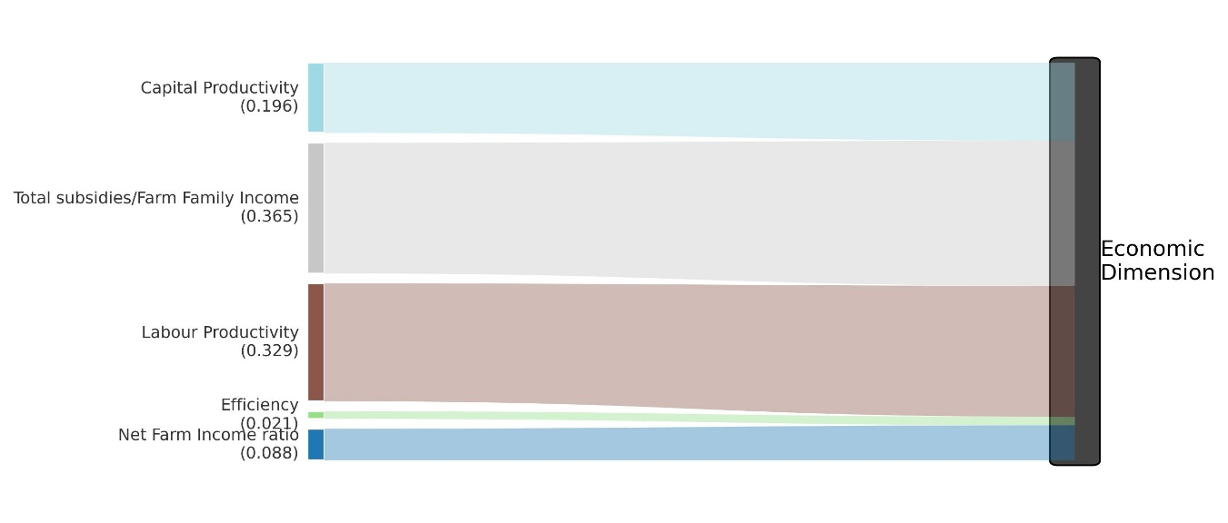
Figure 1 Sankey diagram for the Economic dimension

The environmental dimension (Figure 2) displays an even more concentrated structure, overwhelmingly dominated by Water Intensity (0.395). This identifies irrigation demand and water-use efficiency as the single most distinguishing environmental variable across the EU. Medium-weight indicators—Pesticide Usage (0.176), Livestock Density (0.155), and Fertilizer Usage (0.143)—collectively capture nearly half of the remaining entropy, reflecting differences in chemical pressure and stocking intensity across Member States. Conversely, the Share of Organic UAA (0.094) and Energy Intensity (0.037) contribute minimally, implying that despite political attention, organic adoption rates and fuel efficiency exhibit greater uniformity across the union than anticipated.
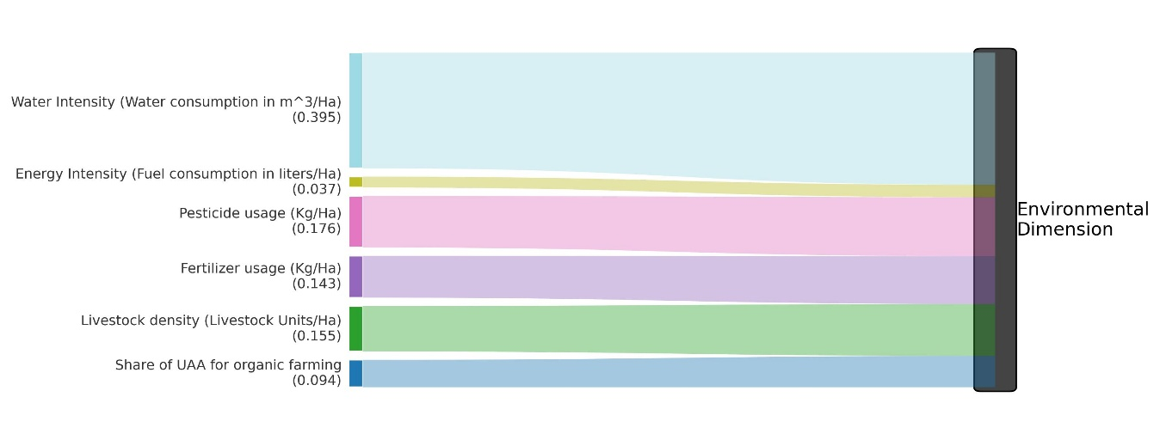
Figure 2 Sankey diagram for the Environmental dimension
In the social dimension (Figure 3), Structural Change Rate (0.375) emerges as the dominant determinant, indicating that demographic transitions—such as farm exits and generational turnover—are the most heterogeneous social phenomena in EU agriculture. The second-largest contributor, Other Gainful Activities (0.262), highlights the role of income diversification in distinguishing social resilience. Meanwhile, Family Farm Income Parity (0.157) and Family Labor Share (0.062) exhibit lower discriminant power, suggesting that the social sustainability of EU agriculture is defined less by labor allocation per se and more by long-term structural dynamics and households' capacity to buffer risks through non-agricultural activities.

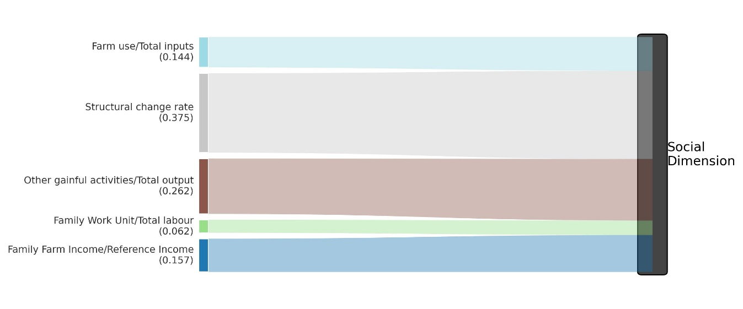
Figure 3 Sankey diagram for the Social dimension
The bar-chart profiles (Figure 4) show that performance rankings are strongly dimension-specific rather than convergent. In the economic dimension, Italy and Denmark lead the distribution, whereas Slovakia and the Czech Republic anchor the low tier. In the environmental dimension, Austria and Sweden are at the top, alongside several Northern/Central systems, whereas Mediterranean and semi-arid systems (notably Spain, Greece, Cyprus, and Malta, with Bulgaria also in the low tier) are concentrated at the lower end. In the social dimension, the highest scores are observed in the East–Central subgroup (Slovakia, Hungary, and Slovenia), whereas Romania, Bulgaria, and Malta remain persistently low performers, and many Western/Southern Member States fall within the medium-low band.
The pairwise comparisons in Figure 5 confirm that the three dimensions do not move in lockstep. With EU means of $μ_{Econ}=0.47$, $μ_{Env}=0.73$, and $μ_{Soc}=0.49$ (dashed lines), several Member States fall into trade-off quadrants rather than the high–high “synergy” space. High economic performance does not guarantee environmental sustainability: Spain and Greece remain emblematic cases with above-average economic scores but clearly below-average environmental outcomes; Italy and Portugal exhibit a similar economic–environmental imbalance. Conversely, several countries achieve strong environmental and/or social outcomes despite weak economic scores—most visibly Slovakia (high environmental and high social with very low economic), and to a lesser extent, Czechia and Finland. A smaller set of cases approaches genuine cross-dimensional performance (e.g., Austria and Hungary), but the overall pattern remains one of partial alignment and frequent compensation across dimensions.

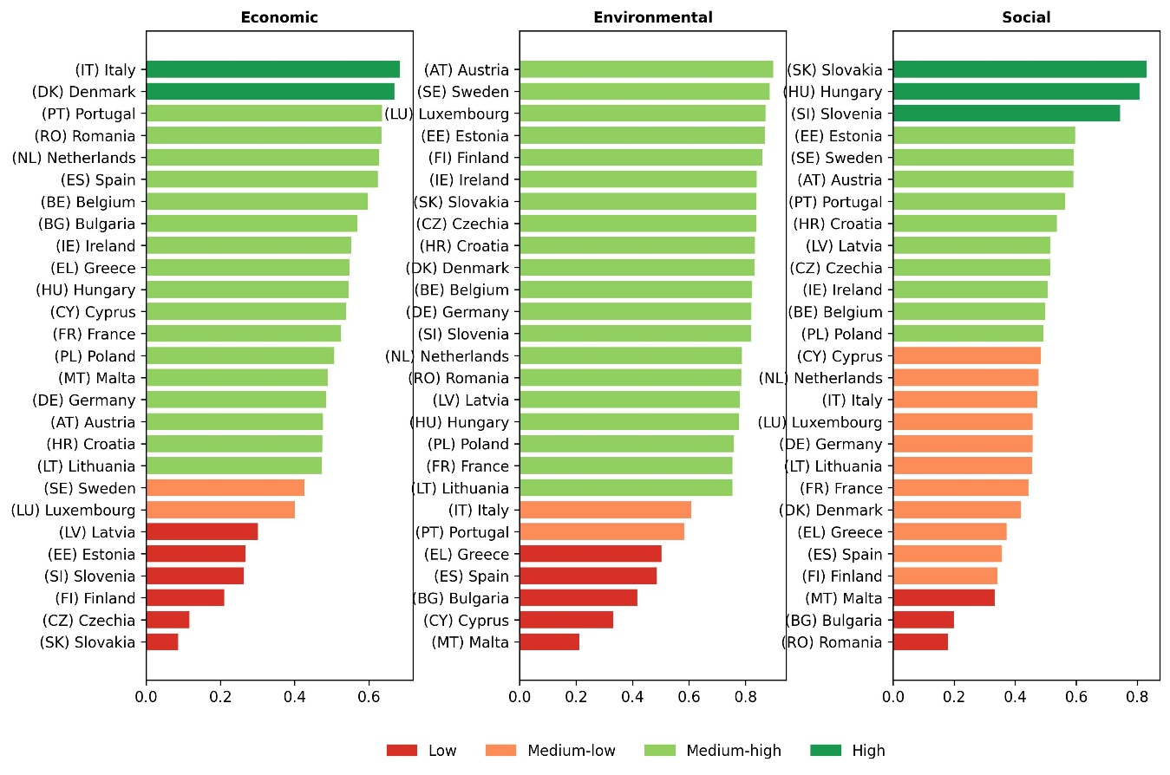
Figure 4 EU bar chart colored by $μ±σ$ classification bands.

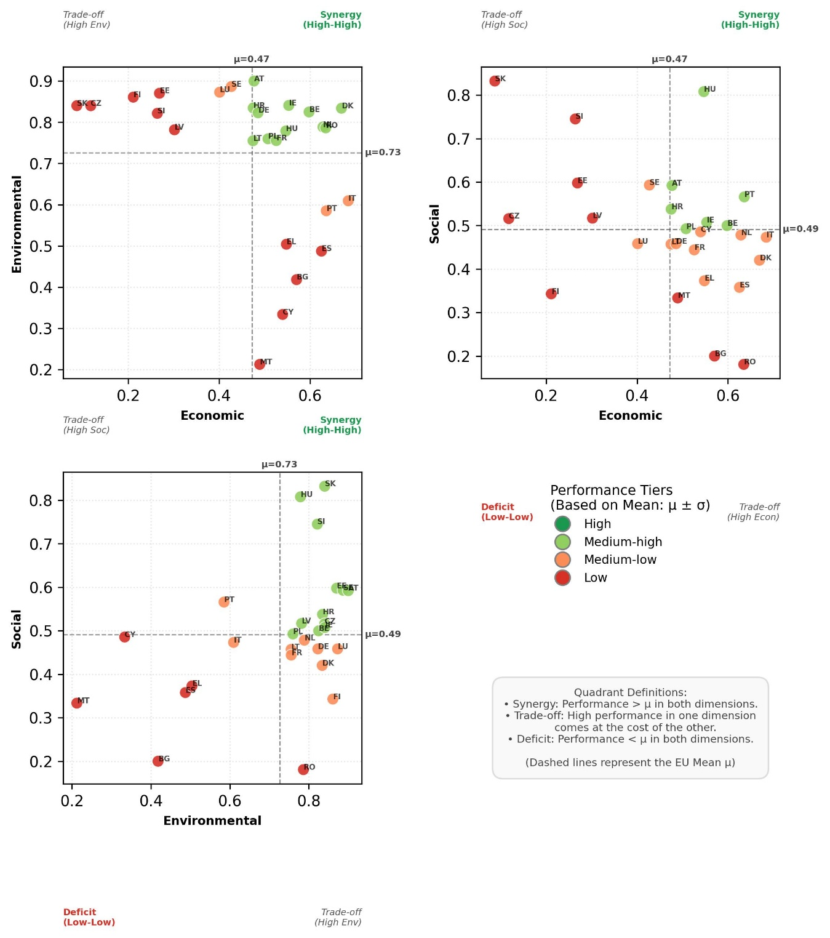
Figure 5 Pairwise score scatter plots colored by $μ±σ$ classification bands.
The geographic maps (Figure 6) indicate that the “fracture” in EU agricultural sustainability is not expressed along a single, uniform axis but varies across dimensions. Environmental performance shows the clearest North/Central advantage, with most Northern and Central Member States clustered in medium- to high tiers, whereas the Mediterranean and parts of the Southeast are concentrated in low tiers. Social performance shows a distinct structure, with an East–Central corridor (e.g., Slovakia–Hungary–Slovenia) standing out positively relative to weaker outcomes in parts of the Southeast (notably Romania and Bulgaria) and generally medium-low outcomes across much of Western/Southern Europe. Economic performance reverses several common intuitions: high tiers are limited (dominated by Italy and Denmark), while several Nordic/Baltic and Central-Eastern systems fall into medium-low to low bands. Taken together, these spatial patterns remain consistent with a “brightspots vs. dragspots” interpretation (Nicholas and Scown, 2024), but the rerun results indicate a multi-speed, multi-dimensional Europe rather than a single cohesive North–South gradient.

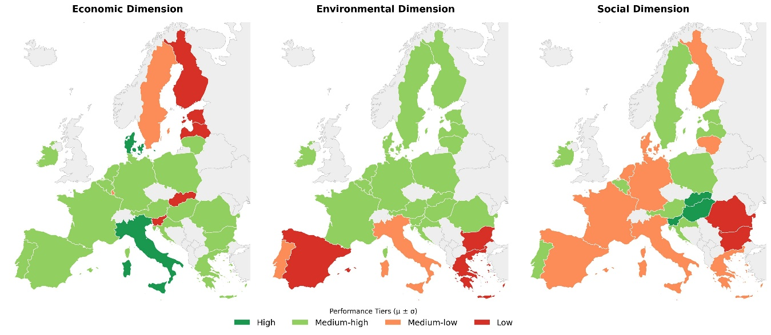
Figure 6 Geographic distribution of composite sustainability levels across the EU-27

Figure 7 illustrates the Gap Statistic validation used to determine the optimal number of clusters ($k$) for the sustainability dataset. The plot displays the Gap value—representing the difference between the intra-cluster dispersion of the observed data and that of a null reference distribution—against potential cluster counts ranging from $k=2$ to $k=10$. The error bars indicate the simulation-based standard error ($s_{k}$) for each value.
.

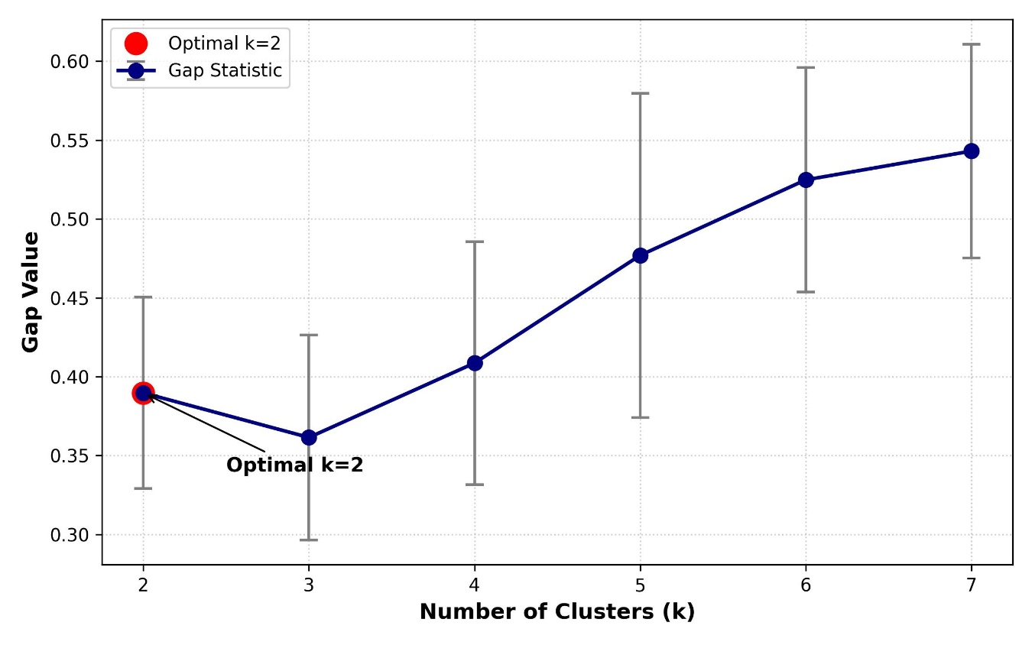
Figure 7 Gap statistics plot

The resulting dendrogram (Figure 8), constructed using Ward’s method, visually confirms this bipartite structure. The tree creates a high-level split that separates the Member States into two clearly defined regimes based on their joint economic, environmental, and social distances.

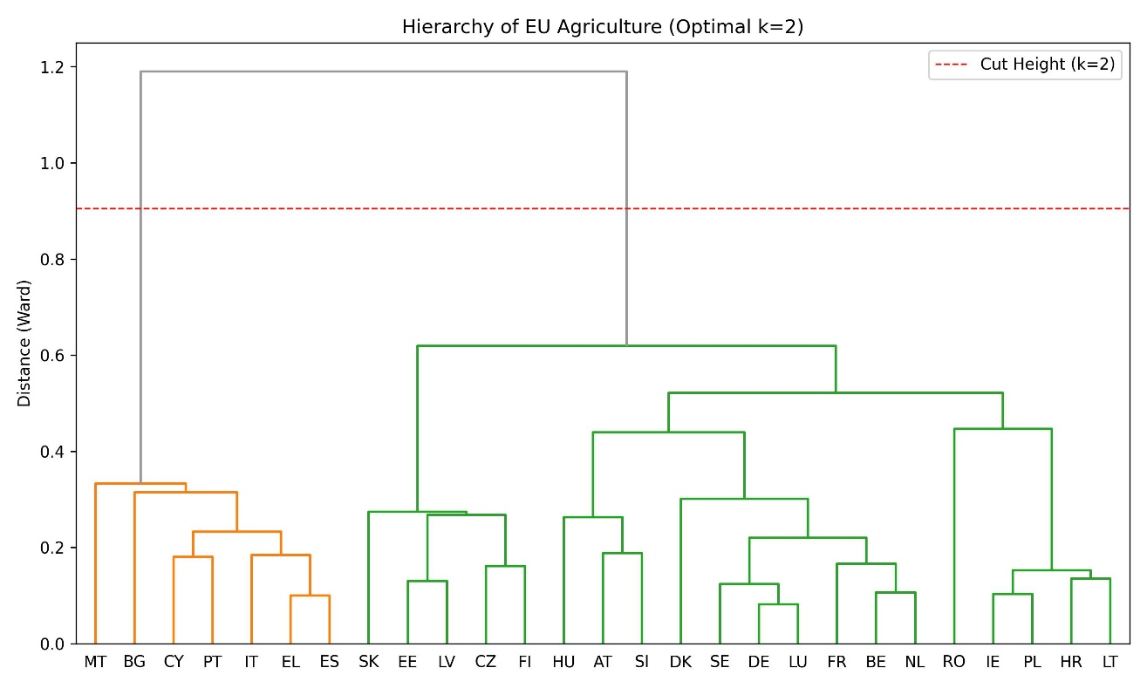
Figure 8 Ward linkage dendrogram cut at the optimal $k$
Cluster characterization (Figures 9–10) clarifies the substantive meaning of this split:
- Cluster 1 (n = 7; MT, BG, CY, PT, IT, EL, ES) forms an economic-leaning but environmentally constrained regime. In the pairwise cluster scatter plots (Figure 9), these countries concentrate at lower environmental scores—often paired with only moderate social outcomes—while maintaining comparatively stronger economic scores. The radar profile (Figure 10) summarizes this pattern as higher mean economic performance coupled with lower mean environmental performance, consistent with a sustainability pathway that relies on economic output under relatively high resource and environmental pressure.
- Cluster 2 (n = 20) represents a broader environmental–social advantage regime. These Member States cluster at higher environmental scores and somewhat stronger social performance, but with more moderate economic outcomes on average. This group includes many Northern/Western systems as well as several Central/Eastern Member States, underscoring that the dominant separation is best interpreted as a contrast between environmental strength versus economic intensity, rather than a purely geographic North–South dichotomy.
The clear separation between the Green and Blue profiles underscores a persistent division. EU agricultural sustainability is best described as a landscape of systematic trade-offs with limited full development, and a statistically supported two-regime structure that isolates a Mediterranean–Balkan cluster characterized by relatively stronger economic scores but weaker environmental performance.

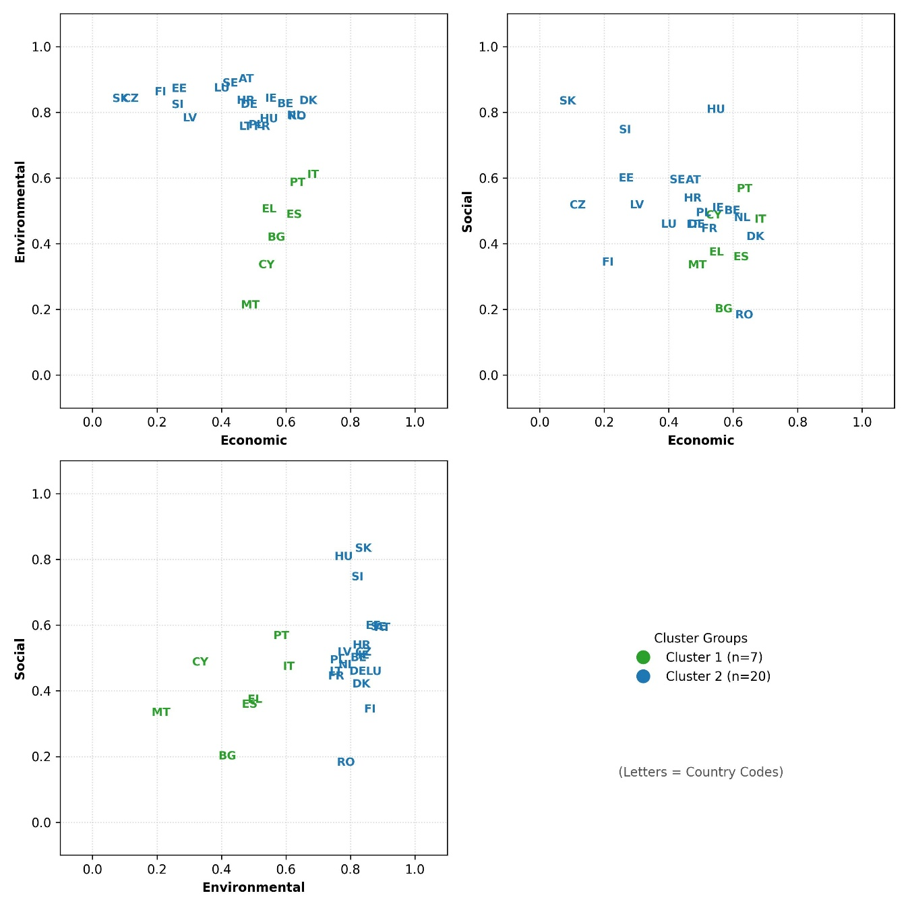
Figure 9 Pairwise score scatter plots colored by Cluster (Green = Cluster 1, Blue = Cluster 2).
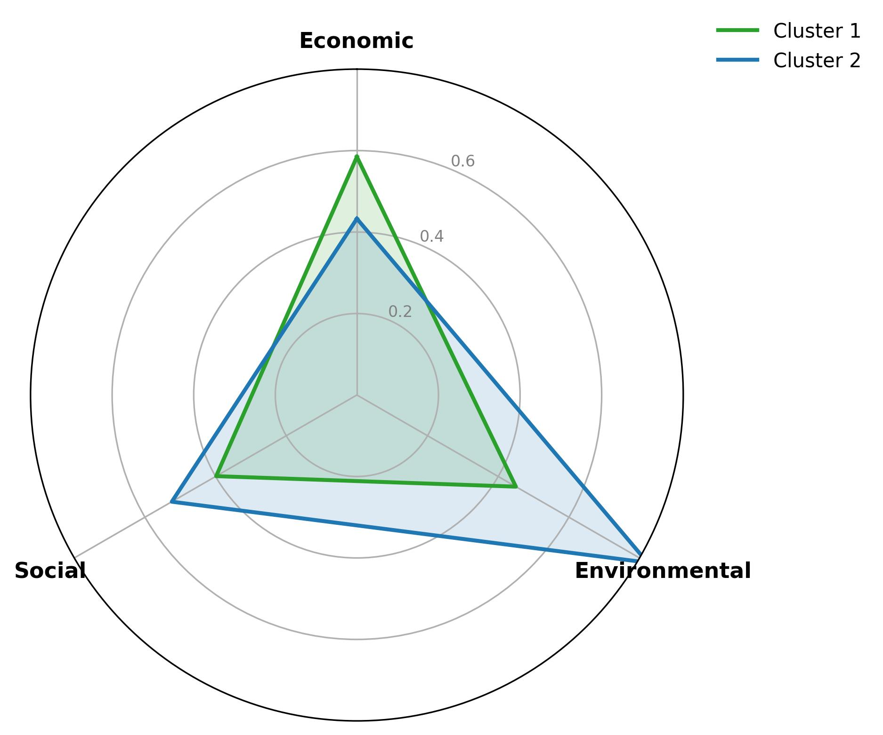
Figure 10 Radar chart comparing the mean sustainability profiles of Cluster 1 (Green) and Cluster 2 (Blue).

References
Dabkiene, V., Balezentis, T., & Streimikiene, D. (2021). Development of agri-environmental footprint indicator using the FADN data: Tracking development of sustainable agricultural development in Eastern Europe. Sustainable Production and Consumption, 27, 2121–2133. https://doi.org/10.1016/j.spc.2021.05.017
Shannon, C. E. (1948). A Mathematical Theory of Communication. Bell System Technical Journal, 27(3), 379–423. https://doi.org/10.1002/j.1538-7305.1948.tb01338.x
Tibshirani, R., Walther, G., & Hastie, T. (2001). Estimating the Number of Clusters in a Data Set Via the Gap Statistic. Journal of the Royal Statistical Society Series B: Statistical Methodology, 63(2), 411–423. https://doi.org/10.1111/1467-9868.00293
Ward, J. H. (1963). Hierarchical Grouping to Optimize an Objective Function. Journal of the American Statistical Association, 58(301). https://doi.org/10.1080/01621459.1963.10500845

